Chamber - benchmark

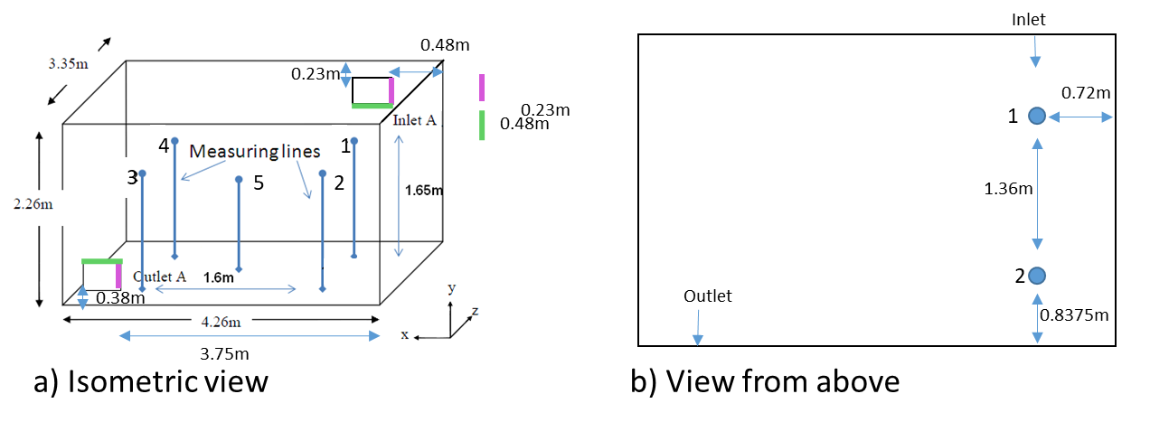

Anemometer measuring velocity magnitude at each vertical line with a frequency of 1Hz.

|  |  |
| --- | --- |
| Line 1. | Line 2 |

Hot-wire anemometer

